#fengtingting1

C:\Users\lenovo\Documents\Tencent Files\741267193\Image\C2C\JWDA2JC%{V{KWLQ(`86%}RM.png

3#fengtingting2

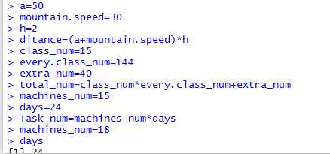

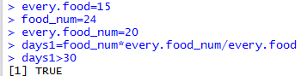

#fengtingting3

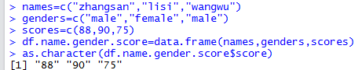

#liujingming1

C:\Users\lenovo\Documents\Tencent Files\741267193\Image\C2C\N29C~ED19$Q$R)K6GV)2RWB.png

#liujingming2

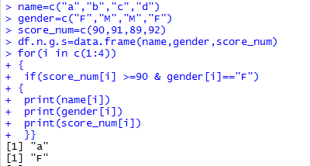

C:\Users\lenovo\Documents\Tencent Files\741267193\Image\C2C\5CCB97K12%C[_E7TV}N}STV.png

#liujingming3

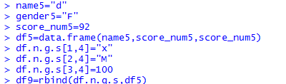

# #liushaosi1

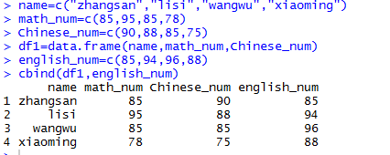

#liushaosi2

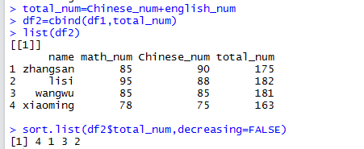

#liushaosi3

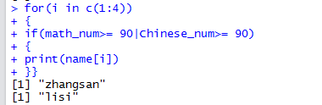

#zhouya1

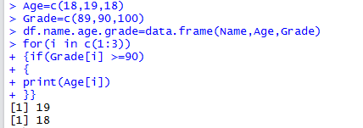

#zhouya2

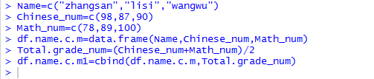

#zhouya3

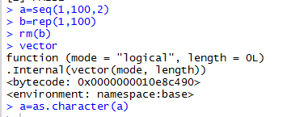

#liushijia1

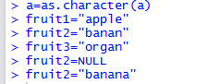

#liushijia2

C:\Users\lenovo\Documents\Tencent Files\741267193\Image\C2C\)6EO2%RWZ%JW5RZGUJ`RYTD.png

#liushijia3

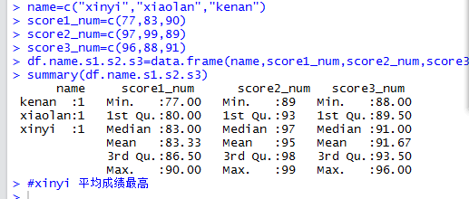

#wuyi1

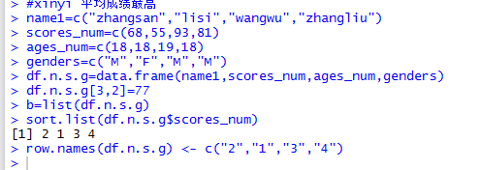

#wuyi2

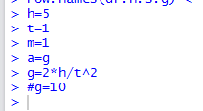

#wuyi3

C:\Users\lenovo\Documents\Tencent Files\741267193\Image\C2C\4)1V8827UHQI%OPQY$JRV71.png

#wuke1

C:\Users\lenovo\Documents\Tencent Files\741267193\Image\C2C\S)L[[U_IP2W[0O([`6~Q%_9.png

#wuke2

#Wuke3

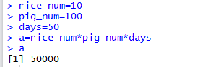

#wuxiafen1

#wuxiafen2

#wuxiafen3

C:\Users\lenovo\Documents\Tencent Files\741267193\Image\C2C\OW_G5N_{3}M96{OV{LXRAR7.png

